**Machu Picchu, Peru**

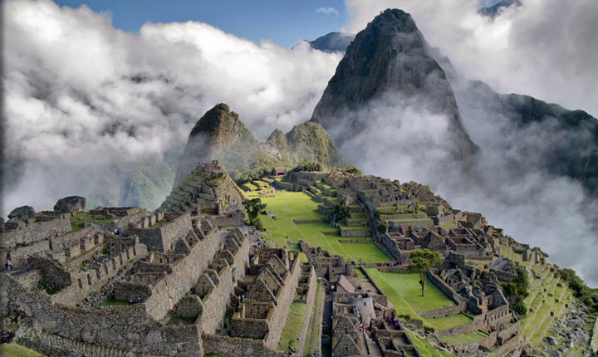

Machu Picchu, located in Cusco region of Peru is one of the new seven wonders of the world and UNESCO World Heritage Site. Also called "Last city of Incas", it is a 15th century pre-columbian site located at 2430 meter above sea level. It is one of most visited tourist destinations in Latin America and most visited in Peru.